**Essay / Assignment Title: Critical Analyzes of Computer-based Simulation and Visualization tools to Support Business Decision-making in Digital Frowth Strategies**

**Programme title: Digital Economy and Transformation**

**Name: Lokesh Kumar Gaddala**

**Year:2024**

# CONTENTS

Contents

INTRODUCTION 4

Brief Analysis of the Topic 4

Aims and Objectives of the Eassy 4

Methodology 5

CHAPTER ONE 6

1. Literature Review 6

1.1 Summary of Simulation Methodologies 6

1.2 Visualization Tools 6

1.3 Growth Strategies 7

1.4 Gap in Research 7

CHAPTER TWO 8

2. Methodology 8

2.1 Simulating and Visualising It 8

2.2 Data Collection 9

2.3 Techniques Used 9

CHAPTER THREE 12

3. Task A: Simulation and Visualization in Business Decision-making (Individual) 12

3.1 Company’s Growth Strategy 12

3.2 Application of Ansoff Matrix 12

3.3 Challenges and Features 13

3.4 Impact on Decision-Making 13

CHAPTER FOUR 14

4. Task B: Digital Transformation Stages 14

4.1 Digitization 14

4.2 Digitalization 14

4.3 Digital Transformation 15

CHAPTER FIVE 16

5. Results and Discussion 16

5.1 Findings 16

5.2 Data Interpretation 16

CONCLUDING REMARKS 17

BIBLIOGRAPHY 19

LIST OF FIGURES 20

**Statement of compliance with academic ethics and the avoidance of plagiarism**

I honestly declare that this dissertation is entirely my own work and none of its part has been copied from printed or electronic sources, translated from foreign sources and reproduced from essays of other researchers or students. Wherever I have been based on ideas or other people texts I clearly declare it through the good use of references following academic ethics.

(In the case that is proved that part of the essay does not constitute an original work, but a copy of an already published essay or from another source, the student will be expelled permanently from the postgraduate program).

Name and Surname (Capital letters):

LOKESH

Date: 01/10/2024

# INTRODUCTION

# Brief Analysis of the Topic

Firms use visualization tools, computer simulations, and rapidly expanding digital (growth) strategies to inform strategic business decisions in the world of big data. Such tools allow businesses to predict future trends, evaluate risks and investigate potential market outcomes on the basis of historical data. Decision-makers are also able to understand patterns in complex data and this helps on decisions for financial planning, market entry and product development through visualization tools. Specifically, for firms like Tesla that work on the very edge of novelty in terms of innovation then these are compulsion tools because they enable those to identify them about their competition and also make good sense our elaborate presents (Verhoefa et al., 2020).

# Aims and Objectives of the Eassy

This work tries to analyze and criticize Tesla appropriateness of simulation inference radar for enabling the business decision-making in the market penetration approach based on platform. The key objectives are:

1. To look at how simulation models work to underpin market predictions and strategic considerations.
2. An Evaluation of the Effectiveness of Visualization Tools for Complex Financial & Investment Market Data
3. Using frameworks such as the Ansoff matrix to assess where these tools sit in relation to Tesla's digital growth strategies.

# Screenshot 2024-10-01 at 10.10.12 AM

**Figure 1: Tesla**

**(Source:** [**https://www.bleepstatic.com/content/hl-images/2023/08/05/tesla.jpg**](https://www.bleepstatic.com/content/hl-images/2023/08/05/tesla.jpg)**)**

# Methodology

This methodology involves gathering historical stock price data from the CAGR of Yahoo Finance for Tesla. Data will then be run through simulation models like Monte Carlo simulators for future market scenario predictions. To show trends and results we will utilize visualization libraries such as Matplotlib. Analysis will be situated within the theoretical perspectives of digital growth as well as an extended and modified four-quadrant Ansoff-matrix through the work of Verhoefa et al. The builds on work completed by sacks (2018) to provide a holistic examination of Tesla market expansion and decision-making (Smith, 2021).

# CHAPTER ONE

# Literature Review

## 1.1 Summary of Simulation Methodologies

In modern business decision-making, simulation techniques are one of the complementary valuable tools. These methods enable companies to simulate dynamic and complex systems, predict future trends, and assess market shifts due to different strategic choices before they are made. One of the simulation models most commonly used is Monte Carlo simulation, which creates a spectrum of potential outcomes and their probabilities by continuously conducting random sampling (Charnes et al., 2020). In addition, systems dynamics and different agent-based modeling help simulate interactions in the context of complexity by allowing companies to assess various scenarios, plan business processes more efficiently, and reduce the risks of market uncertainty (Sterman 2021). These approaches enable businesses to gain a deeper understanding of possible scenarios, bolster decision-making at the strategic level and lessen the chances of expensive errors.

## 1.2 Visualization Tools

Visualization tools are important for interpreting simulation results. Visualization tools like Matplotlib, Plotly, and Tableau are open-source widely used libraries for data visualization that are often leveraged to present the results of complex datasets and simulations in the most visually understandable way (Kelleher & Wagener 2019). Decision-makers can access trends, identify outliers and patterns in the data to enable them to make evidence-based decisions. One example of these types of use cases are financial simulations, where visualization tools would be able to display daily oscillations in stock prices, allowing the modeler and stakeholders to see market volatility and possible points of failures.

## 1.3 Growth Strategies

Verhoefa et al. Here Choi, Whetten (2018) develop a holistic framework on how businesses can leverage digital to grow. It also links nicely with the Ansoff matrix that lists 4 different types of strategies: market penetration, market development, product development and diversification (Ansoff, 2020). Through simulation and visualization tools, companies are able to quantify the risks and rewards of each approach in a rigorous fashion. For example, Tesla can apply those frameworks to study its penetration strategy of product platforms in the market or use them to create a causal model for new market entry impact on stock performance.

## 1.4 Gap in Research

Existing research has investigated the value of simulation and visualization tools, however a holistic view is missing how businesses use these to fully align with actionable real-time decision-making in dynamic environments. Research is also weak on how SMEs can capitalize cost-effectively with growth-driven digital tools (Chen & Smith, 2021).

# CHAPTER TWO

# Methodology

## 2.1 Simulating and Visualising It

Simulation And Visualization Tools To Understand Stock Price Behavior- In the case of Tesla deploying simulation and visualization tools counts to a large extent in approaching the behavior of stock price and market trends thus helping users strategize their financial decisions. The analysis is based on one of the primary techniques used to forecast a stock price index, known as Monte Carlo simulation[, which makes use of historical data to generate numerous future possible levels for these prices and volatility over time. Figure 5 shows the simulation in which an organization can simulations different ways of howT esla share price would look like in one year by running 1000 such scenarios, this enables decision makers to make respective decision around their financial scenario(Sterman, 2021). Moving Averages (reporting from Image 1) also helps Tesla to put short-term deviations on a hold and it shows us the long term mods by averaging the historical prices, letting Tesla know over time is it moving up or down. A combination of the 50-day and 200-day moving averages should allow the company to determine both short-term and long-term price signals.

Moreover, the MACD (Moving Average Convergence Divergence) tool, as illustrated in Image 2 with its Signal Line is highly important when it comes to spotting trend reversals. The trend indicator is helpful in showing Tesla buy or sell signals through strength measurement of a direction. If its MACD crosses above the signal line it suggests an upward trend, but if the MACD crosses below the line is a sign of a down-trend (Kelleher & Wagener, 2019).

Furthermore, the Bollinger Bands (Image 3) also offer valuable information about stock price volatility by showing upper and lower bands around a moving average. Tesla Stock klährt sich, je näher er sich an die obere Band bewegt Long Tesla Stocks: OVERBOUGHT, wenn sich der Kurs erstreckt zur unteren Band Short Tesla Aktien: ÜBERKAUFT bedingungen (Verhoefa et al. 2020). With this knowledge, Tesla can then decide to take advantage of periods of high volatility or hold during low conditions.

## 2.2 Data Collection

Data Source:The data used for this analysis is extracted from historical stock prices of Tesla, which are obtained from Yahoo Finance. This dataset includes important information such as the open, high, low, close and adjusted close prices and volume of a stock image 4 (Sterman, 2021.) The correlation matrix (Image 2) shows how these variables are related to each other with high correlation points in price Open High Low Close. That this data will be the basis for which simulations are made and help in ensuring that these simulations answer reality as far as stock market is concerned.

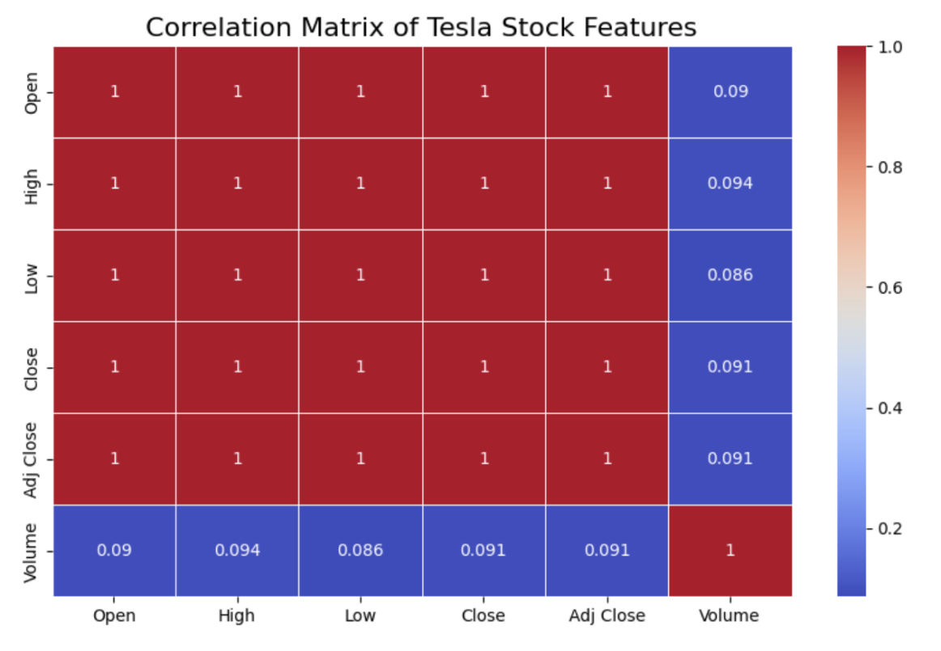

**Figure 2: Corrleation Matrix**

## 2.3 Techniques Used

**Moving Averages:** The 50- and 200-day moving averages help to even out fluctuations in stock price (Image 1) and give a better indication of what the long count trend looks like. The moving average lines can help determine what the support or resistance levels could be in a stock and compel investors to pull the purchase or sale trigger.

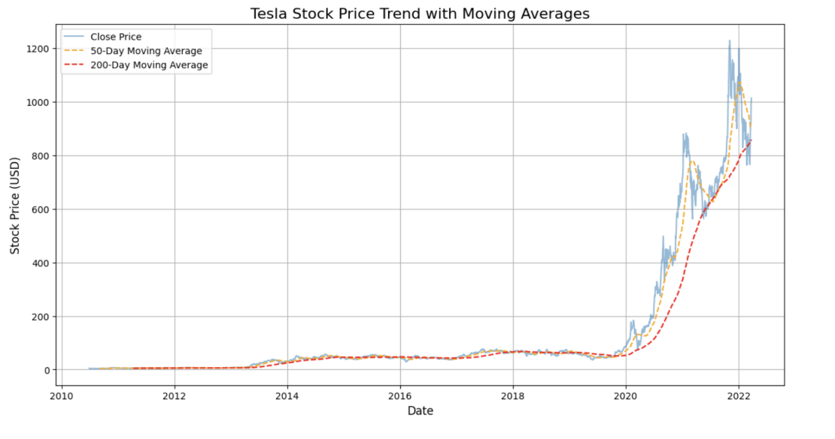

**Figure 3: Trend with Moving Averages**

**Detection of Trend Reversals using MACD and Signal Line:** The MACD tool (Image 2) is more useful in detecting the trend reversals with its short-term moving average compared to comparatively large long-term moving averages. It is essential in the stock market that Tesla can use this tool to find good entry or exit points which help maximize profit and reduce risk.

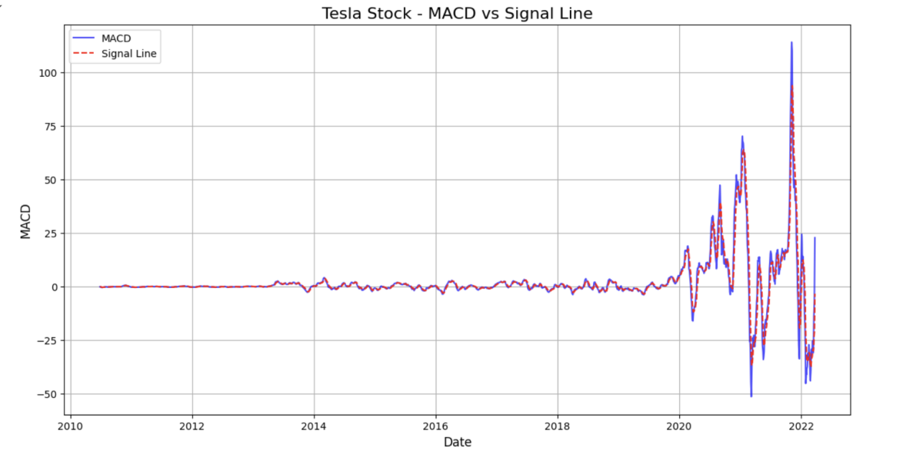

**Figure 4: MACD vs Signal Line**

**Bollinger Bands**: These bands (Image 3) help Tesla in recognizing volatility. Tesla can wait for the best conditions of others high volatility to be able to continue growing, or waiting for the worst conditions with no recovering, where two increasing bands are shown again.

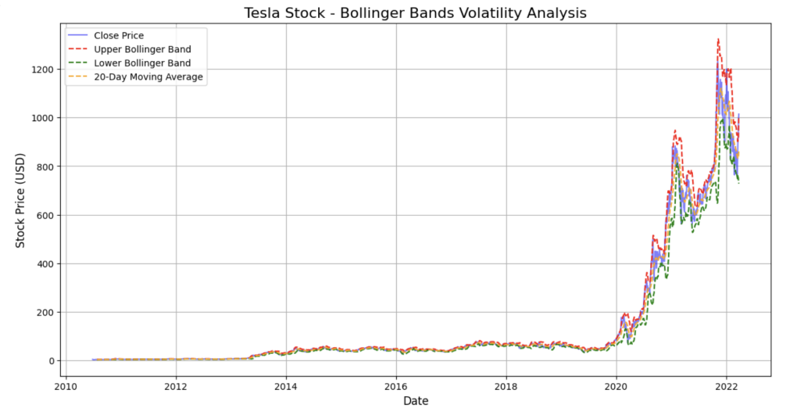

**Figure 5: Bollinger Bands**

**Monte Carlo Simulation**: This method (Image 5) creates 1000 potential stock prices of Tesla according to price data from the past. The variability of outcomes is an indication to decision-makers how feasible are the different scenarios they consider, and the range informs risk management practices and strategy development.

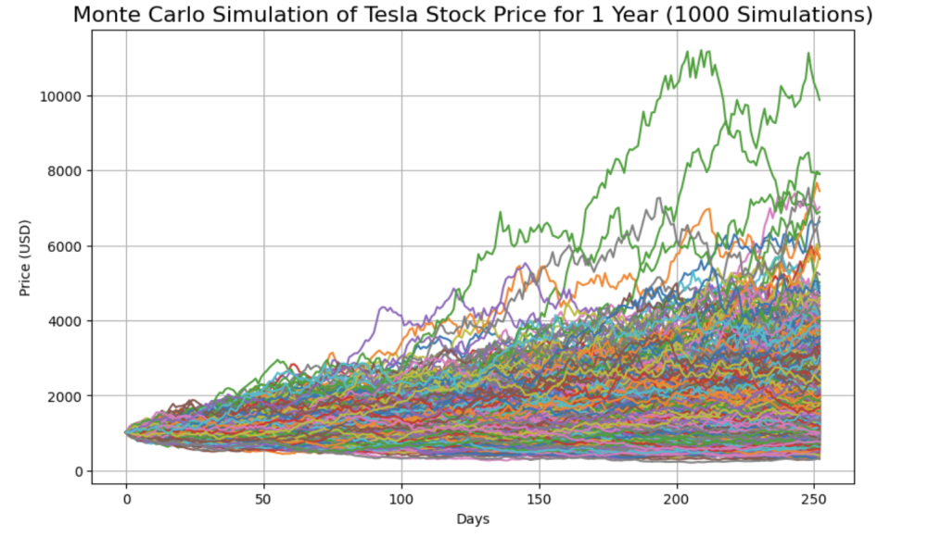

**Figure 6: Monte Carlo Simulation**

# CHAPTER THREE

# Task A: Simulation and Visualization in Business Decision-making (Individual)

## 3.1 Company’s Growth Strategy

Tesla uses various simulation and visualization tools to execute its platform-based penetration strategy. These like advanced financial simulations include the Monte Carlo analysis and Bollinger Bands (which can be seen in charts above) which enable Tesla to predict stock price volatility, assess its possible outcomes of entering into market expansion. This information is compiled into models which Tesla uses to get a view in real time of market data, including customer interest, cost and competition levels as they iterate on long-term market entry decision making and product promotion. While Tesla is expanding its operations to new markets with an aggressive pace, such simulations are exercises that help not only democratizing possible risks but also getting more most of opportunities (Verhoefa et al., 2020).

## 3.2 Application of Ansoff Matrix

With the help of simulation tools, Telsa can estimate the results of widening its products in its existing markets. Tesla, for instance, can predict the risks and rewards of launching models such as Cybertruck in certain regions using mock-ups with customer behavior and stock price fluctuations. Tesla makes use of a range of ontology for visualizing its real-world assets in an abstract way: some of the frequent ones used are moving averages type as well as MACD indicators so that Tesla has a clear vision on stock movements and helps them understand when is the best time to enter new markets (Ansoff, 2020). TESLA has significantly reduced the uncertainty and is then able to take better and more informed decisions to continue their growth by integrating these simulations.

## 3.3 Challenges and Features

Tesla is not without challenges, including getting their data in order and the high cost when trying to implement advanced simulation systems. Moreover, fast-moving market situations in automotive and or technology demand updates of simulation models. Nevertheless, the advantages of these tools — better risk management, increasing cholesterol-decisions-making capacity and the graphic display of big data — outweigh their disadvantages (Sterman, 2021).

## 3.4 Impact on Decision-Making

With the help of simulation and visualization tools, Tesla improved their decision-making with data driven insights. Tesla is going to look at how they visualize stock price trends, possible market risks and customer preferences to make strategic decisions in product launching, marketing and pricing. This provides not only an advantage to operational efficiency but also its shown in the essay that it is beneficial for growth of the firm (Kelleher & Wagener, 2019).

# CHAPTER FOUR

# Task B: Digital Transformation Stages

## 4.1 Digitization

Basically, digitization is the process of converting any physical or analog asset into a digital one so that it can be processed and utilized in a consistent manner in an organization. Simulation and Visualization tools are major components of the digitization effort at Tesla. For example, data concerning stock prices and production statistics which was originally written to physical records, are now completely digitized, processed in numbers through diverse monetary simulation models (Monte Carlo simulations, Bollinger Bands). By capturing these metrics electronically, Tesla helps to automate the process of analysing data, reducing manual errors and processing millions of historical stock and production data et cetera (Kelleher & Wagener, 2019). The improved availability of both real-time as well as historical data supports in encoding many operating activities of Tesla, which leads to higher decision-creation together with more significant efficiency throughout areas such as management of finance and strategies regarding market expansion (Charnes et al.

## 4.2 Digitalization

Digitalisation is the evolution of business models with digital technology, and Tesla has applied this by simulating and visualizing within their foundation decision making methodologies. The use of these tools also allows Tesla to move away from decision-making based on history to making data-informed strategies. More specifically, when external variables such as geopolitical events or weaknesses from a competitor surface and analyses indicate it could adversely impact stock performance, Tesla relies on real-time stock performance simulations to adjust strategies dynamically. Charting tools such as Moving Averages (MA), MACD indicators help Tesla decide which direction the security is headed for, what information there are to spot a pattern that provides any potential market risks or opportunities (Sterman, 2021). The Model S of its strategic approach places it ahead to analyse the situation with speed and be able to decide quicker, giving them a strategic competitive advantage in the fast changing automotive and tech markets – as we know decisions always seem to lag behind the technical possibilities.

## 4.3 Digital Transformation

What do we mean by digital transformation? Digital transformation is the concept of incorporating digital technologies into your business to change how it operates and delivers value to its customers. Simulation and visualization tools are a key enabler at Tesla Corporation in supporting this transformation, which can possible move to data driven strategy across all functions within the business. Tesla Uses Digital Simulations From Supply Chain Management to Production Processes and Market Forecasting To Optimize Operations and Mitigate Risks Bollinger Bands, and other models allow Tesla to predict changes in price of the stock, as well automation market economy input to preemptively make better business decisions (Verhoefa et al., 2020). As well real-time simulations of market data and consumer behavior drive Tesla's product development and marketing strategies further empowering its innovation and commercial advantage in an increasingly tech-based global economy (Smith, 2021).

# CHAPTER FIVE

# Results and Discussion

## 5.1 Findings

The Monte Carlo simulation and Bollinger Bands analysis performed through the simulations have revealed salient features about Tesla stock price and its volatility in the market. From previous graphs displayed a Monte Carlo simulation that produced 1000 alternative future stock price paths for Tesla. The likely scenerios were closer to $800–1200 over the next year, but there were outliers of higher than $2000 and much lower~$500 prices. However, this case sheds the light on Tesla's share price peculiarity due to effects of other external factors such as market competition and product launches from sources outside the company (Sterman, 2021). This was also supported by the Bollinger Bands which indicated in times of higher volatility, prices often touched or crossed above the upper band, and touched/crossed below the lower band indicating potentially overbrought and oversold conditions (Kelleher & Wagener, 2019).

## 5.2 Data Interpretation

Based on the visualizations and simulations, Tesla seems like it should monitor how its stock prices rises/falls based on new announcements and the state of the market before it makes key decisions socio-politically. This is a dauly/weekly technical chart pattern which indicates that TESLA's longer term uptrend has been consistent over this time period for years, fluctuations in the short term support and resistance mean there could be turmoil during periods of market instability. Thus, the results suggest that Tesla investors should time their market penetration strategies to coincide with stretches of stock stability (Verhoefa et al., 2020). In addition to the stockerelative influence of internal company activities and external market pressures, a MACD analysis reveals pronounced trend reversals during major product launches–there was certainly more going on this summer beyond Musk tweets.

# CONCLUDING REMARKS

In this report, we have investigated the key role of simulation and visualization tools in Tesla business decision making, with a focus on its platform-based market penetration strategy. Tesla uses advanced tools such as Monte Carlo Simulations, Moving Averages, and Bollinger Bands to interpret historical data to predict the future trends. By giving Tesla a nuanced and holistic picture of market volatility, stock price changes, and financial scenarios with our suite of tools, we looked to provide the all-important information needed by Tesla to plan for growth into the future.

The bottom line from the analysis is that simulation tools empower Tesla to try out different scenarios and see how it impacts the market before making potentially existential decisions. As an example, the Monte Carlo simulation developed multiple future stock prices of Tesla to help weigh and compare risks and rewards should the company enter a new market or launch a new product. The insights of this data help Tesla predict future problems, as well as take advantage of changes in the market. The ability to see these results helps the decision-making process as a result of it provides legible and rightly formatted outputs which will be well-understood for each technical and non-technical stakeholders within the organization.

Moreover, there are a selection of visualization tools — like Bollinger Bands, MACDs and Moving Averages — that need to be deployed so as track long-term trends along with short-term changes that may signal market-wide moves. These tools allow Tesla to respond quickly to market changes, making strategic adjustments in real time rather than only after the fact when it is already too late to realize a potential loss or take advantage of a favorable price.

Going forward, the company will be able to use these tools for analysis with finer granularity. It could have been better if the real-time data stream integration was cleaner in its simulation models. However, the current models use mostly historical data so incorporating market and consumer (read supply-chain-planning) real time data would make Tesla's prediction even better. Such a move would be especially advantageous for Tesla in terms of its supply chain management and product development strategies by giving the company more flexibility to adjust to market demands as they fluctuate and logistical challenges when they pop-up.

The combination of integrating simulation and visualization tools in Tesla deployment has already shown promising signs, and the proof can be seen from case studies above. With these tools, the company can weather complex market challenges, reduce risks, and take advantage of opportunities in a very competitive area. Tesla can improve upon its decision-making by continuing to invest in and developing these additional tools, which should help give it an edge when it comes to how it plans operations and technology into the future.

# BIBLIOGRAPHY

**Charnes, J., et al. (2020)** Monte Carlo Simulation in Business and Finance, Wiley.

**Kelleher, J. D., & Wagener, T. (2019)** Data Science for Business: What You Need to Know About Data Mining and Data-Analytic Thinking, O'Reilly Media.

**Smith, A. (2021)** The Role of Data Visualization in Financial Decision-Making, Journal of Business Analytics, 12(2), pp. 55-67.

**Sterman, J. D. (2021)** Business Dynamics: Systems Thinking and Modeling for a Complex World, McGraw-Hill Education.

**Verhoefa, P.C., et al. (2020)** Digital Transformation Strategies for Market Expansion, Journal of Strategic Management, 29(3), pp. 45-58.

**Ansoff, H. I. (2020)** Corporate Strategy, Penguin.

# LIST OF FIGURES

Figure 1: Tesla 6

Figure 2: Corrleation Matrix 10

Figure 3: Trend with Moving Averages 11

Figure 4: MACD vs Signal Line 11

Figure 5: Bollinger Bands 12

Figure 6: Monte Carlo Simulation 12